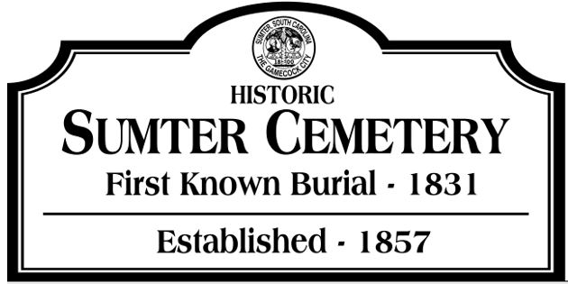
SUMTER CEMETERY MEMORIAL BRICK PROGRAM

Included in the construction of the Veterans Memorial built in 2024 at the Sumter
Cemetery is a 3 ft brick walkway around the memorial. This walkway is made up of 4” x 8” red engravable paving bricks and these bricks are available to the public for engraving to celebrate the lives of their veterans, family, and friends. Proceeds from this program will cover engraving costs and provide funding for memorial construction, historical projects, and cemetery enhancements.

- Engraved memorial bricks cost $75 each.
- Bricks will be engraved in blocks of at least 10 so there may be a
wait before your bricks are engraved. You will be contacted when your
brick(s) are engraved. Bricks are engraved on site.
- We cannot take requests for specific location on walkway for your engraved bricks. This will be determined by the monument company that does the engraving.
- Engraving space will allow for 3 lines of 13 numbers, letters,
abbreviations and/or spaces on each line.
- Requests for each brick will be reviewed and inappropriate
wording will be rejected.
- Bricks may be purchased for those living or those that have passed and for
those family/friends buried anywhere…not just at this cemetery.
- Checks should be made out to Sumter Cemetery Association and indicated
for ‘Brick Program’.
- Checks should be mailed to: Sumter Cemetery Association
Memorial Brick Program
209 Haynsworth St
Sumter SC 29150
Please contact Robert Pemberton at 919-410-3825 for cash payments.
- Please complete one form for each brick. Payment can be made by
single check for all bricks requested.
10.Please include all required contact information.
11.If you have any questions, please call 919-410-3825

SUMTER CEMETERY MEMORIAL BRICK
REQUEST FORM

Name: _______________________________________________________
Address: ______________________________________________________
Email: _________________________________________
Phone: ________________________________________
Please enter what you would like on your brick…3 lines max, 13 characters
per line (including letters, numbers, punctuation, and spaces).

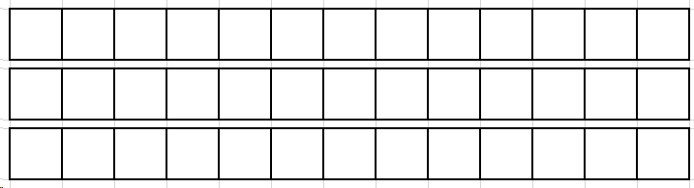

Please use 1 form per brick, form may be copied for multiple bricks.
Cost is $75.00 per brick: Payment: □ Cash □ Check
Payment should be made to the Sumter Cemetery Association. Checks only
should be mailed to:
Sumter Cemetery Association – Memorial Brick Program
209 Haynsworth St. - Sumter SC 29150
Please attach all forms for requested bricks.

Internal use only below this line:

Payment received: Date: ___________ Engraving Done: Date: __________

Purchaser Notified: Date: ____________

